

###### **JIMMA UNIVERSITY**

***COMMUNITY BASED TRAINING PROGRAM (CBTP)***

***(Demographic survey and problem Identification Phase I)***

***At* *Hermata kebele***

*Conducted by;-*

* *CBTP Group 5*

*Supervised by;-*

* Mr.Kokeb Desse
* Mr.Tewdrose Belay

*Submitted to;-*

 *CBE Office*

**May 2021 GC**

**GROUP NAME ID number**

**1. ESAYAS BIZUNEH………………………..……..…….……….RU1163/12**

**2. EYOAB ASEGID………………………………..…………..…...RU1214/12**

**3. EYOB BEZU…………………………………………….………..RU0360/12**

**4. EYOSIYAS MENGESHA …………………………...……….…RU0132/12**

**5. FIKRE AYELE….…………………………….…………............RU2004/12**

**6. FIRAOL GIRMA…………………….…………….…………….RU0036/12**

**7. GENET BIRHANU………………………………...….…………RU0158/12**

**8. KAYO KUMSA……………………………………..…………….RU1544/12**

**9. KIBRU G/MEDIHIN……………………………..……..…..……RU1913/12**

**10. KIDUS TAMIRU…………………………..……………..……...RU2190/12**

**11.EYOB KASSA…………………………………………………..RU3507/11**

ADVISOR :Mr.KOKEB DESSE

:Mr.TEWDROSE BELAY

Table of content

Acknowledgment 7

Abstract 8

CHAPTER ONE 9

1.1 Introduction 9

1.2 Methodology and materials 9

CHAPTER TWO 14

Household, Socio-economic and demographic data 14

2.1 Age Distribution 14

2.2 Sex Distribution 16

2.3 Religion Distribution 16

2.4 Level of Education 17

2.5 Occupation Status 18

2.6 Martial status 19

2.7 House ownership status 19

2.8 Range in number of rooms 20

2.9 Types of House 21

2.10 Type of Roof 21

2.11 Ceiling of the house 21

2.12 Type of wall 22

2.13 Type of wall finishing 23

2.14 Type of the floor finishing 23

2.15 Type of the foundation 24

2.16 Type of latrine availability 25

2.17 Disposal of refuse 26

2.18 Type of waste drainage disposal system 27

2.19 Ventilation method………………………………………………………………………28

2.20 Availability of kitchen…………………………………………………………………..29

2.21 Cleaness of the house……………………………………………………………………30

2.22 Maintinance requirement of the House………………………………………………….31

CHAPTER THREE 32

WATER SUPPLY and SANITARY SITUATION 32

3.1 Types of water supply 32

3.2 Transport system 32

3.3 Communication 33

3.4 Biomedical Equipment……………………………………………………………………34

3.5 Small scale industry………………………………………………………………………34

3.6 Waste disposal……………………………………………………………………………34

3.7 Places disposing refuses………………………………………………………………….35

CHAPTER FOUR 37

4,1 CONCLUSION 37

4.2,RECOMMENDATION…………………………………………………………………37

Appendix.1……………………………………………………………………………………..38

Appendix.2……………………………………………………………………………………38

Appendix.3……………………………………………………………………………………39

Reference……………………………………………………………………………………39

List of table

Table 2.1 Age status 12

Table 2.2 religion composition 14

Table 2.3 Level of education 15

Table 2.4 Occupation status 16

Table2.5.marital status 16

Table 2.7 Ownership Status 17

Table 2.8 Range in number of rooms 18

Table 2.9 Types of House 18

Table 2.11 ceiling of the house 19

Table2.12 Types of Wall 20

Table 2.13 type of wall finishing 20

Table 2.14 Type of the floor finishing 21

Table 2.15 type of foundation 22

Table 2.16 type of latrine available 23

Table 2.17 disposal of refuse 23

Table 2.18 types of waste drainage disposal system 25

Table2.19 Ventilation method 26

Table 2.20 Availability of kitchen 26

Table2.21 Cleanness of the houses 27

Table 2.22 Maintenance requirement 28

Table 3.1.Types water supply system 29

Table 3.2 Availability of latrine 32

Table 3.3 Places people dispose their refuses 33

List of Figure

Figure 2.1 Analysis of age interval using pie chart 14

Figure 2.2 Sex Distribution 15

Figure 2.3 Pie chart of religion composition 16

Figure 2.4 Level of education 17

Figure 2.4 occupational status 18

Figure 2.5 marital status 19

Figure 2.7 Ownership Status 19

Figure 2.8 Range in number of rooms 20

Figure 2.9 Type of house 21

Figure 2.11 ceiling of the house 21

Figure 2.12 Type of wall 22

Figure 2.13 type of wall finishing 23

Figure 2.14 Type of the floor finish 24

Figure 2.15 type of foundation 24

Figure 2.16 type of latrine available 25

Figure 2.17 Disposal of refuse 26

Figure 2.18 types of waste drainage disposal system 27

Figure 2.19 Ventilation method 28

Figure 2.21 Cleanness of house 29

Figure 3.1 types of water supply system 31

Figure 3.1 communication 33

Figure 3.2 Avilability of latrine 35

Figure3.3 Places people dispose their refuses by percentage 36

# Acknowledgment

In the process organizing the community based education (CBE) project First and foremost we would like to extend our gratitude to the lord almighty God or Allah for helping us to accomplish the assignment.

Secondly, we would like to thanks the community of HIRMATA for giving us information to better about the community problem they are dealing with.

Thirdly, we would like to extend our thanks to Jimma university car and meal service, the Pre-engineering office.Fourthly,our special thanks goes to our advisor Mr. KOKEB on behalf of his valuable support suffusion,encouragements and offering use full hints. And for all the workers in kebeles for giving us a good response for all questions we had kindly.

Lastly not the least we would like to thank to all our group members for valuable support their effective participation on the project.

# Abstract

The CBE (community based education) was conducted with the general and specific objective in identifying the problem of the community’s and the problem of the small scale industries in the power supply, housing, medical, transportation problem and any other community problems.

The study is expected to provide base line information concerning the problem faced by the community.

This report deals with about house hold socio-economic and demographic which include socio- demographic characteristics like sex, religion, age and ethnicity ,level of education , occupation and marital status ,house hold like income and asset of family ,availability of biomedical facility such as health limitation ,type of service given to the community from health institutions and family health care, availability of small scale industries and finance in the Hermata kebele.

A questioner was the dominate data collection tool for going to study a lone with unstructured interview and personal observation. These sampling procedure for the selection of sample from the entire population lastly, based on the findings of the study we expected that the study must revealed some valuable new facts and suitable recommendation and conclusion for warded to improve the performance of power supply system in Hermata kebele.

.

# CHAPTER ONE

## 1.1 Introduction

### 1.1.1 Definition of CBTP (community based training program)

CBTP is an institutional program which runs in phases from first year to graduation along with an in-built regular follow up program. Each phase has specifically defined educational objectives. During each phase students as a group (8-10) are assigned to urban, semi-urban or rural communities.

### 1.1.2 Background of Hirmata kebele

Hirmata is found in Jimma town. The whole areas in Hirmata consist of 10,080 peoples, from which 5268 are males and 4812 are females. The number of houses reaches about 2016; as researches show in 2013E.C. the prominent feature of the community can be stated as follows. Many of the community members are literate and do jobs like business jobs. The other thing that is well-known in the community is that they participate actively in all of the following economic and social activities.

* Helping handicapped, old and infirm peoples
* They also try to win challenges that they face in their day to day life by working hard.

|  |  |
| --- | --- |
| **1.Total population** | **10080** |
| 2.No of male | 5268 |
| 3.No of female | 4812 |
| 4.Total no of Household | 2016 |
| 5.No of children <1 year | 1590 |
| 6.No of children 6-59 months | 1452 |
| 7.No of women 15-49 years | 2142 |
| 8.Estimated pregnant mother | 336 |
| 9.No of none pregnant women | 1803 |
| 10.NO of children 24-59 month | 1038 |

**The kebele is bounded by:**

**Direction Boundary Keble**

* North…………………………………………………....Bosa kito
* South ……………………………………………………Hirmata Mantina
* East……………………………………………………… Hirmata merkato
* West……………………………………………………..Mantina kebele

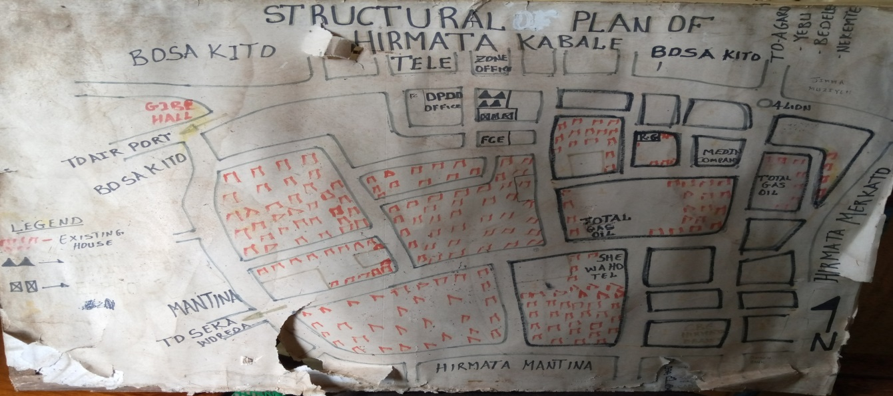

## 1.2 Methodology and materials

### Subject of the study

We have studied the Hirmata kebele, to gather reliable information; we use certain methodology to make our work easy and effective. For instance, the whole students in our group are 10. We all works in pair as our advisor told as.

### Data source

As we concerned in the data source, it is obviously that we have gathered our data from the community and from the kebele administrator. We started our data collection by introducing ourselves to the community of Hirmata kebele. We recorded the information about the family from whom ever we got in the house. That enabled us to analyze information we got from the family.

### 1.3.3 Materials

During our data collection, we use different equipment that are available for collecting data. These equipment’s are:

* Pencil
* Paper
* Rubber
* Blade(sharpener)
* Binder
* Pen

### 1.3.4 Methods of data collection

During our field work we use different methods of data collection to gather information from the community. These methods helped us for the quality of our studying program. In this case, our data was collected through qualitative, quantitative and simple sampling methods of data collection. The different methods of data collection we used are stated below:

* Observation
* Interview
* Questionnaires’
* Note taking
* Group discussion

**1.3.5** Procedures

The questionnaires are prepared by pre-engineering office and CBTP coordinators. Then these questionnaires were distributed to the respective groups of students by our coordinator.

The university Bus service is provided for students to take them to the selected community and after fieldwork, return to the campus. Each team has gone to their respective community with their supervisors in order for their mission of data collection.

Each team of student was on work field for one days. First,we visited the area of the community with their boundary and data was collected from the sample of the community by house to house questioning and lastly general information is gathered from the kebele administrator and some persons.

After we have finished data collection, we discussed by coming together with our group members and started to write our report in order to present what we have been doing.

**1.4** Background of CBE

CBE is an educational philosophy aimed at developing future professionals with problem identification and solving skills and positive attitude to serve the society. It is an educational approach rooted in the believe that, if the objective of the education is to equip learners with realistic, practical and relevant knowledge, skills and attitude that would contribute to the improvement of life of the people it shouldn’t be limited to classroom activities only. Rather it has to take place in the community where learners meet the final goal of education; community development and social change.

***CBE follows the problem solving steps. These are:***

* Site selection( identifying community)
* Developing investigation tools
* Gathering data
* Processing and analysis of information
* Listing and prioritizing problems
* Drawing action plans
* Carry out interventions
* Evaluation by involving students, teachers, the community, governmental and non-governmental development agents in a concerted manner. **of CBE**

**1.4.1** General objectives

1. Redirect the learning approach to focus on population, groups and individual taking the development needs of the community involved.
2. To train different professionals who should be responsive to the needs of the community through a development approach to improve the lives of the society by all stake holders.
3. To demonstrate social accountability by initiating or participating in training, research and service at local, national and international levels.

**1.4.2** Specific Objective

1. Produce new professionals who are responsive to the development needs of the society.
2. Involve the community in the problem solving processes of learning for development.
3. Empower the community to address its development needs with the local resources.
4. Work with governmental and non-governmental organizations to improve the lives of the society through peoples approach.
5. Promote development through multidisciplinary team approach.
6. Undertake community based researches to identify and solve society problems.

**1.5** Components of community based education (CBE)

To realize the aforementioned objectives, three programs (strategies) are designed, namely:

* Community based training program( CBTP)
* Development team training program( DTTP)
* Student research program( SRP)

The term community has been operationally defined to mean groups of people who share common interest and have the feeling that they belong together to form a community, whether it is in urban or rural setting.

The three strategies above were all employed and provided with comprehensive knowledge and also provide the community with direct or indirect benefits.

DTTP is the form of different senior of professional students working together in one piece.

SRP is the program which is pre-found advantage of giving students experience allow to do their own research project.

**1.6** Community based training program (CBTP)

From the three strategies of CBE, explained above, it is one of them. This CBTP has two phases, namely; CBTP – I and CBTP – II.

CBTP – I is one of the strategy of CBE which is designed for undergraduate year-I students where students are assigned to urban, semi-urban and rural community and engage themselves in developmental activity needs of the community.

There are varieties of course objectives such as community problem identification, data analysis using statistical principles, priority setting, action plan development and scientific report writing and presentation. CBTP-I is also a means of achieving educational relevance to the community needs and implementation of a community oriented educational programs. .

**1.8** Significance of the study

**CBTP-I** has so many importance to identify the major problems of the community in the kebele. Some these advantages are:-

* To aware community about their duty and responsibility.
* To motivate students to solve the problem of the community in the future. I.e. on CBTP-II depend on problem identified.
* To identify the problem this is shown in the community regarding economic, social, political, cultural and health.
* To help the students to get experience and to identify the problem in the future easily.

**1.9** Limitation of the study

* Few of the community members were not volunteered to give us full information.
* Some of us faced language problem.
* We didn’t cover the whole area of the kebele due to shortage of time and questionnaire.
* Due to the sunny season we were tired of the intensity of the sunlight.

**CHAPTER TWO**

# Household, Socio-economic and demographic data

## 2.1 Age Distribution

According to our sample which is taken from 36 houses and 103 people of Hirmata kebele, we classify the age status of the community into four according to the following table.

#### Table 2.1 Age status

|  |  |  |
| --- | --- | --- |
| **Age interval** | **Number of people** | **Percentage** |
| **0-18** | **39** | **41.05%** |
| **19-30** | **30** | **31.5%** |
| **31-50** | **15** | **15.78%** |
| **50<** | **11** | **11.57%** |

Figure 2.1 Analysis of age interval using pie chart

##### 

we can clearly see that the number of age interval 19-30 is greater than all the other age interval by accounting 25.24% OUT OF 100% of the sample on the research. This amount shows there is potential productive manpower.

**2.2** Sex Distribution

When we come to the gender of the community of Hirmata percent of female (47.5%) is less than the number of male (52.5%). The research done by the group also shows the same thing.

**We can also see this graphically:**

##### Figure 2.2 Sex Distribution

**2.3** Religion Distribution

Jimma zone is one of the regions of Oromia which consist of different religions. The same is true in Hirmata kebele. The majority of the community in this kebele are Muslim followers. The rest are protestant and Orthodox religion followers respectively.

#### Table 2.2 religion composition

|  |  |  |
| --- | --- | --- |
| Religious | Number of followers | Percentage |
| muslim | 34 | 35.78% |
| Orthodox | 27 | 28.42% |
| Protestant | 23 | 24.21% |
| Other | 11 | 11.57% |
| Total | 95 | 100 |

Figure 2.3 Pie chart of religion composition.

During our analysis as we asked the kebele leader and the community, we were told that the number of Muslim religion followers is greater than the others. Our research also shows the same thing as we were told.

**2.4** Level of education

According Hirmata kebele the number of peoples who are educated and uneducated isn’t known but according to our research sample, we classify the level of education of the community according to:

* Uneducated
* Elementary school
* High school
* College/university
* Graduates

#### Table 2.3 Level of education

|  |  |  |  |  |
| --- | --- | --- | --- | --- |
| Level of education | | Number of people | Percentage | |
| Uneducated | | 11 | 11.57% | |
| Elementary school | | 21 | 22.1% | |
| High school | | 18 | 18.94% | |
| College/university | | 17 | 17.89% | |
| Graduates | | 28 | | 29.47% |
| Total |  | 95. 100 | | |

Figure 2.4 Level of education

**2.5** Occupation Status Distribution

Although there are different types of Jobs in Hirmata the report classify them into seven type according to:

* Merchants( shopkeeper )
* Laborers( shoeshine, cleaner, wood worker, waiter, security)
* Employees( teacher, manager )
* Students
* Unemployed( retired, housewives, …)

#### Table 2.4 Occupation status

|  |  |  |
| --- | --- | --- |
| Occupation | Number of people | Percentage |
| Merchants | 15 | 15.78% |
| Laborers | 5 | 5.26% |
| Employed | 8 | 8.42% |
| Students | 56 | 58.94% |
| Unemployed | 11 | 11.57% |
| Total | 95 | 100 |

## 2.6 Marital status

In Hirmata kebele according to our research. The number of single, married, widowed and divorced families can be stated as follows by table and graph.

Table2.5.marital status

|  |  |  |
| --- | --- | --- |
| Marital status | Number of people | Percentage |
| Single | 37 | 38.94% |
| Married | 42 | 44.21% |
| Widowed | 4 | 4.21% |
| Divorced | 12 | 12.63% |
| Total | 95 | 100 |

##### Figure 2.5 marital status

## 2.7 House ownership status

Out of the 25 houses we visited 7 of them were private owned, 8 of them were rentals, and 11 of them were all kebele homes.

|  |  |  |
| --- | --- | --- |
| Types of Ownership | Number of house | Percentage (%) |
| Private | 7 | 28% |
| Rental | 8 | 32% |
| Kebele | 11 | 44% |
| Total | **25** | **100** |

#### Table 2.7 Ownership Status

##### Fig2.7 Ownership Status

## 2.8 Range in number of rooms

|  |  |  |
| --- | --- | --- |
| Number of Rooms | Number of homes | Percentage (%) |
| 1 | 2 | 8% |
| 2 | 8 | 32% |
| 3 | 13 | 52% |
| More | 2 | 8% |
| Total | **25** | **100** |

#### Table 2.8 Range in number of rooms

Fig 2.8 Range in number of rooms

## 2.9 Type of Houses

In Hirmata according to our research we didn’t found any house that is from other than brick, wood or blocked, but the number of wooden, brick and Blocked houses can be stated as followed by table and graph.

|  |  |  |
| --- | --- | --- |
| Type | Number of houses | Percentage (%) |
| Wooden | 10 | 40% |
| Brick | 7 | 38% |
| Blocked | 6 | 24% |
| Other | 3 | 12 |
| Total | **25** | **100%** |

#### Table 2.9 Types of House

##### Fig 2.9 Type of house

## 2.10 Type of Roofing

Based on our data observed 100% people use Corrugated iron sheet for their house.

## 2.11 Ceiling of the house

Based on the data collected in some areas ceiling is present 24% of ceiling made from chip wood, None of ceiling made from wood and 56.07% of ceiling made from plastic fiber and 20% of ceiling made from Garment and both are wood and no ceiling 0%.

|  |  |  |
| --- | --- | --- |
| *Ceiling type* | *Number of houses* | *% composition* |
| *Chip wood* | *6* | *24%* |
| *Wood* | *0* | *0 %* |
| *Plastic fiber* | *14* | *56.07%* |
| *Garment* | *5* | *20%* |
| *No ceiling* | *0* | *0 %* |
| *Total* | ***25*** | ***100*** |

#### Table 2.11 ceiling of the house

##### Fig 2.11 ceiling of the house

## 2.12 Type of Wall

Out of the total number of the house 20%% of the walls are built from brick. House that are built from wooden make up 80%.

|  |  |  |
| --- | --- | --- |
| Type of wall | Number of users | % composition |
| Brick | 5 | 20% |
| Wooden | 20 | 80% |
| Total | 25 | 100 |

#### Table2.12 Types of Wall

Fig 2.12 Type of wall

## 2.13 Type of wall finishing

Out of the total number of the house 16% of the wall finishing are built from soil or mud. The wall finishing that are plastered and painted are 64% and 20% are only plastered.

|  |  |  |
| --- | --- | --- |
| Type of wall finishing | Number of houses | % composition |
| Only plastered | 5 | 20% |
| Plastered and painted | 16 | 64% |
| Soil or mud | 4 | 16% |
| Total | **25** | **100** |

#### Table 2.13 type of wall finishing

##### Fig 2.13 type of wall finishing

## 2.14 Type of the floor finishing

Out of the total number of the house 12%of the floor finish is terrazo,8% of the floor finish is marble, the cement render also occupies 60%, the mud occupies 16%, and no finishing 4%.

|  |  |  |
| --- | --- | --- |
| Type of floor finish | Number 0f house | % composition |
| Marble | 2 | 8% |
| Terrazzo | 3 | 12% |
| Cement render | 15 | 60% |
| No finishing | 1 | 4% |
| Other(mud) | 4 | 16% |
| Total | **25** | **100** |

#### Table 2.14 Type of the floor finishing

##### Fig 2.14 Type of the floor finish

## 2.15 Type of the foundation

|  |  |  |
| --- | --- | --- |
| Type of floor finish | Number of house | % composition |
| Stone masonry | 14 | 56% |
| Concrete | 7 | 28% |
| No foundation | 4 | 16% |
| Total | **25** | **100** |

In engineering foundation is the corner stone of one’s building. out of the total number of data 56 % of the house are made from stone masonry, 28% of the house are made from concrete foundation, and 16% of the rest has no foundation.

#### Table 2.15 type of foundation

##### Fig 2.15 type of foundation

## 2.16Type of latrine available

Humans must keep their health well. To do this good latrine is important. From the collected data 76% of the people use pit latrine,24% of the people use ventilator improved pit, and 0% of the people has no latrine.

|  |  |  |
| --- | --- | --- |
| Type of latrine available | Number of houses | % composition |
| Pit latrine | 19 | 76% |
| Ventilator improved pit | 7 | 24% |
| No latrine | 0 | 0% |
| Total | **25** | **100** |

#### Table 2.16 type of latrine available

##### Fig 2.16 type of latrine available

## 2.17 Disposal of refuse

Materials which are not clean must be removed by using different techniques. From the collected data 47.2 % of the people use pit, 48% of the people use open filled,12% of the people use municipality service 24%.

|  |  |  |
| --- | --- | --- |
| Disposal of refuse | number | % composition |
| Pit | 12 | 48% |
| Open filled | 3 | 12% |
| Municipality service | 6 | 24% |
| other | 4 | 0 |
| total | 25 | 100 |

#### Table 2.17 disposal of refuse

##### Fig 2.17 Disposal of refuse

## 2.18 Type of waste drainage disposal system

The liquid wastes may be removed by different techniques.16% of the people use septic tank, 48% of the people use open filled, 16% of the people use open ditch.

|  |  |  |
| --- | --- | --- |
| Types of liquid wastes | Number of house | % composition |
| Septic tank | 4 | 16% |
| Open filled | 12 | 48% |
| River | 0 | 0 |
| Open ditch | 4 | 16% |
| Total | **25** | **100** |

#### Table 2.18 types of waste drainage disposal system

##### Fig 2.18 types of waste drainage disposal system

## 2.19 Ventilation Method

Getting fresh air is the most the necessary thing for human beings. Ventilation is the removal of used air and replacing it with clear and fresh air. It could be accomplished by using doors, windows and ventilation devices. In the town we surveyed most of the houses use doors and windows as ventilation method.

|  |  |  |
| --- | --- | --- |
| Type | Number of houses | % composition |
| Door only | 8 | 32% |
| both | 17 | 68% |
| total | 25 | 100 |

#### Table2.19 Ventilation method

##### Fig 2.19 Ventilation method

## 2.20 Availability of kitchen

In any type of home, the availability of kitchen is not questionable. Especially it must be clean and it has to be separated and wide depending on the standard of design. Based on our observation in Hirmata kebele 60 % have a kitchen and the remaining 40% has no kitchen.

|  |  |  |
| --- | --- | --- |
| C | Number of the house | Percentage% |
| Yes | 15 | 60% |
| No | 10 | 40% |
| Total | **25** | **100** |

#### Table 2.20 Availability of kitchen

##### Table 2.20 Availability of kitchen

## 2.21 Cleanness of the House

In spite of the low level of living standard, the cleanness of the house is some how appreciable. Above 16% of the house has fair condition, 60% are in good condition and 24% are in bad condition.

|  |  |  |
| --- | --- | --- |
| Cleanness of the house | Number of houses | % composition |
| Good | 15 | 60% |
| Fair | 4 | 16% |
| Bad | 6 | 24% |
| total | 25 | 100 |

#### Table2.21 Cleanness of the houses

Fig 2.21 Cleanness of house

## 2.22 Maintenance Requirement of the Houses

Maintenance of the house is important in order for it to continue as a shelter as it is a basic necessity for humans.

|  |  |  |
| --- | --- | --- |
| Condition | Number | % composition |
| Good | 10 | 40% |
| Fair | 5 | 20% |
| Poor | 6 | 24% |
| Need maintenance | 4 | 16% |
| Total | **25** | **100** |

#### Table 2.22 Maintenance requirement

# 

# CHAPTER THREE

# 3 WATER SUPPLY, TRANSPORTATION AND COMMUNICATION

## 3.1 Types of water supply

In Hirmata kebele There are many source of water such as, pipe, rain, ground water etc. in this kebele there is no protected as well as unprotected spring water source.

|  |  |  |
| --- | --- | --- |
| Water supply system | Homes | Percentage |
| Pipe (yard tap) | 23 | 92% |
| Well | 2 | 8% |

#### Table 3.1.Types water supply system

##### Figure 3.1 types of water supply system

Depending on the above table and pie chart the percentage and frequency of pipe(yard tap) is greater which accounts 91.67% out of the total random sample of population . Next to that the people who use well accounts 8.33%. Lastly the community who used protected spring with piped system accounts.

Generally, from the collected data we can decided that, even though the scarcity of water supply is run on is some range but there is a society who does not get a good quality of water .Due to this problem the governmental organizations are trying to contract a new reservoir .Then we believe that after the accumulation of the reservoir there will be enough water supply.

**3.2** Transport system

During our analysis of CBE program in Hermata kebele,most of the transport method is vehicle as it is in the middle of the city it can be(private/public).

Condition to the road is fair but it is not good at some places it needs maintinace as a result of this there is some issues regarding about the drainage system.

As we mentioned earlier there is no traffic light in the kebele and the residents of the kebele can go to important places of the town by asphalted road,and there is no road that requires bridge.

In the case of pathways, there are enough pathways made of cobblestone and asphalt. But in the case of traffic light there exist no traffic light in this kebele. They also don’t have solar, wind, water powered appliances in the kebele.

In case of agriculture the kebele doesn’t use agriculture and there is no future plan that the kebele thought to improve the agriculture in the kebele.The community in this kebele doesn’t have awareness in the community about biogas technology.

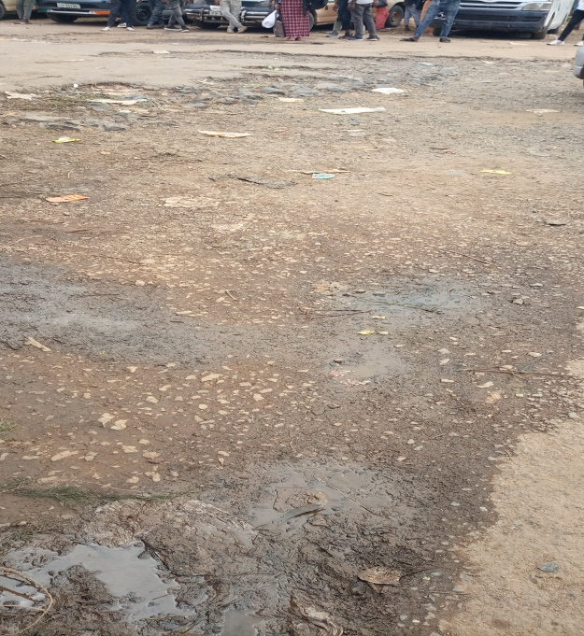

**3.3** Communication

Telephone is available everywhere in the hermata kebele and the community is using the communication more than any other kebeles in the city and much of the residents use mobile as a means of communication.

##### 

#### Fig 3.1 communication

**3.4** Biomedical equipment

There are 2 private health institutions (clinic) and there is no government or public health intuition in the vicinity and there are no non- functional equipment’s.

There are handicapped individuals in the community and this private health institution is not enough addressing all the community, they need additional health institutions.

**3.5** Small scale industry

There are so many small scale industries in the hermata kebele and this small scale industry include:-

* Furniture
* Small markets
* Groceries
* Small cafeterias

There are no raw materials found in the kebele but there are some available fruits such as:

* Avocados
* Bananas etc……

## 3.6 Waste disposal

Waste disposal is the process of removing of unwanted material a ways from the users of families and recycling them in proper manner. A moving this disposal latrine is one of the almost all the community they used. Sanitation: any system promotes proper disposal of human and animal wastes proper use of toilet and avoiding. Also refers to the provision of facilities and service for the safe disposal of human urine and faces or latrine.

#### 

|  |  |  |
| --- | --- | --- |
| Types of latrine | Homes | Percentage (%) |
| Pit latrine | 16 | 64 |
| Ventilated | 7 | 28 |
| Water carriage | 2 | 8 |
| Total | 25 | 100% |

#### Table 3.2 Availability of latrine

##### Figure 3.2 Avilability of latrine

As we shown from above table we conclude that almost many houses have latrine that is above 69.45% which is high than house which have no latrine. But the all latrine type of pit latrine. The problem around this is that since that latrine is pit it failed in short period of time.

## 3.7 **Places of disposing refuses**

People who live in Hirmata kebele dispose their refuse in different place.The following table shows places where people dispose their refuses and frequency of refuses.

|  |  |  |
| --- | --- | --- |
| Places | Homes | Percentage (%) |
| Pit | 12 | 48% |
| Open field | 3 | 12% |
| Municipality service | 6 | 24% |
| Labor force | 4 | 16% |
| Total | 25 | 100% |

#### Table 3.3 Places people dispose their refuses

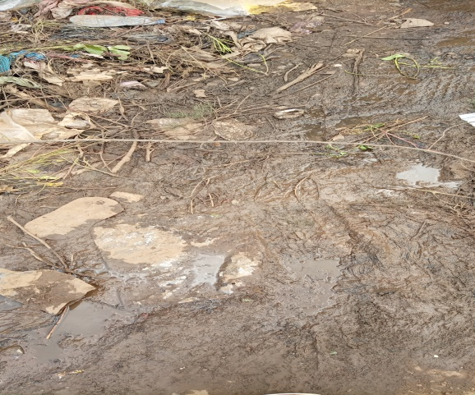

As we observed from the above table 41.09% of the Hirmata people use labor force refuse disposal.

##### Figure3.2 Places people dispose their refuses by percentage

**CHAPTER FOUR**

## 4.1 **CONCLUSION**

We have tried a lot to summarize different points we mentioned in previous chapters regarding demographic computation in the community we have divided the community to religion, level of education, ethnicity, occupational status and marital status.

One thing we have observed in Hermata kebele is that most of the population participates in sanitation, area cleaning, construction of the school and other things. example, few of them participate in helping handicapped old and in afforestation.

Generally, in socio-economic status

* Most population of Hirmata kebele are male
* In religion distribution most population are Muslim
* The least population are in higher education
* Most of them are married.
* Most population get clean water.

## 4.2 RECOMMENDATIONS

CBTP is a good way of learning practice. Therefore, students must give attention it and the community must give the correct information so as to identify their problem.

The following points should be done to solve the problem that arises from community students and university after each data collection with in short period of time as much as possible:

* Significant role should be played by non-government organization to find the solution,

and the government should also participate.

* concerning the program;awareness should be given to the community to gather information.
* The community should be cooperative with the university and student.
* As much as possible, university identify social problem
* Creating a plat form which will make the people is the government to overcome the problem of roads as to safety of the society.
* Enabling the society to announce the problem of the population by discussion.
* Increasing awareness on biogas.
* Giving awareness to the society to create job opportunity by collaborating with micro financial institutions and governmental sectors.
* Developing awareness of the society to have clean and qualified latrine and giving enough information about the effect of this things.

## APPENDIX



Appendix.1………………………………………………………Questioner1



Appendix.2………………………………………………………Questioner2

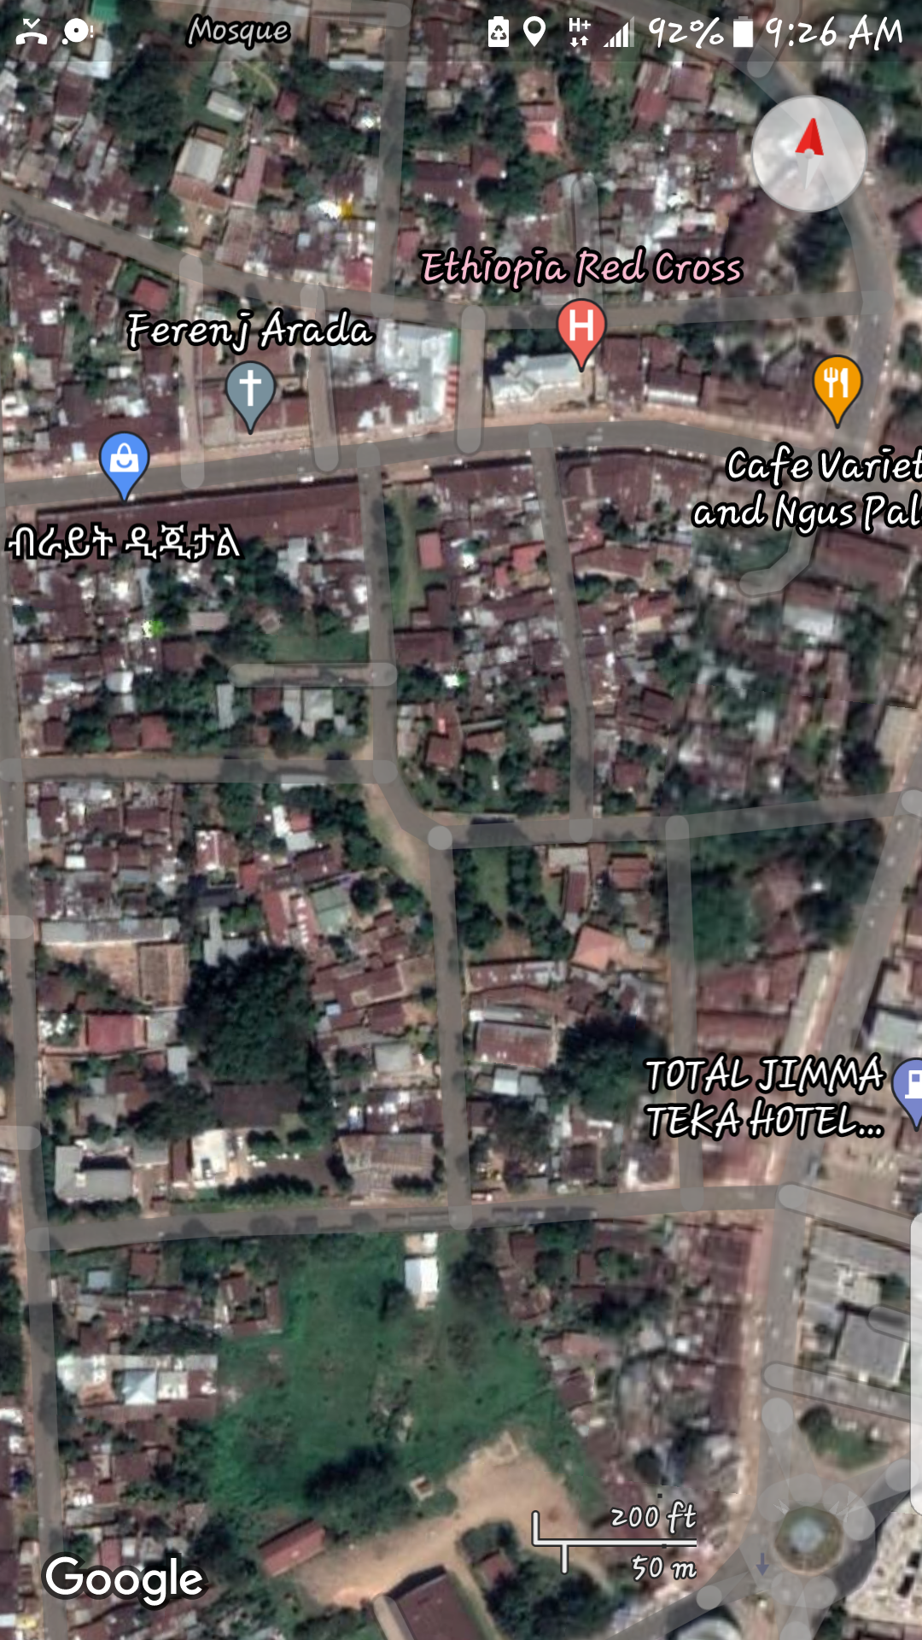

Appendix.3…………………………………………………………Map of hermata kebele

## Reference

* Statics data of the community(kebele) and Senior Students
* CBTP coordinators.